The Traditional Métis Sash is a very symbolic aspect of Métis culture and Métis identity.
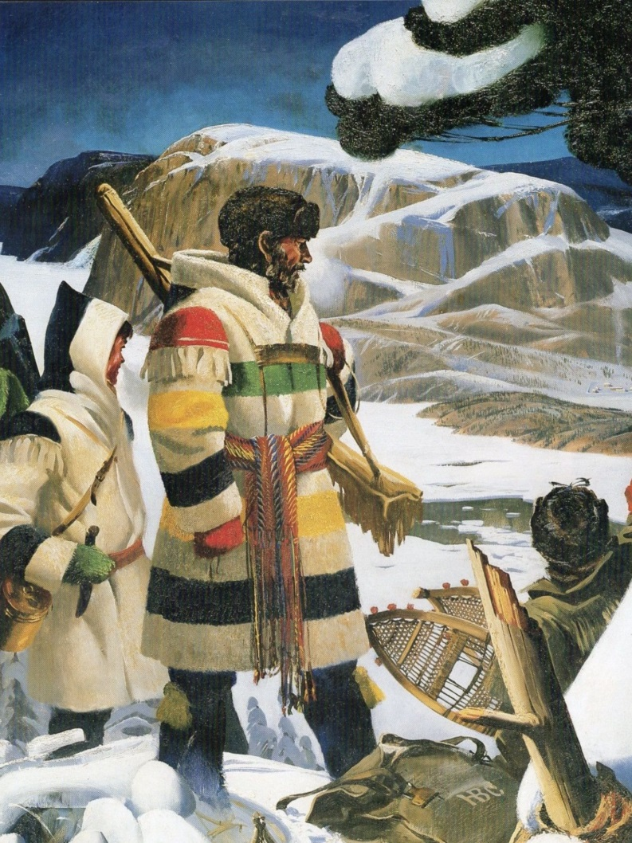
“As early as 1650, a finger woven wool sash was worn by voyageurs of French and First Nations heritage as a sign of their occupation. During the exchange of culture between the Europeans and the First Nations the inspiration of the wampum belt evolved into the Métis sash. With the supply of wool from the Hudson Bay Company and the Northwest Company, sashes began to be made in bright colours and patterns. By the early 1800’s the sash became an important trade item and was sold to the Red River Métis and the French Canadians. Eventually the HBC started manufacturing the sashes on looms, but the art of finger weaving sashes has been retained and is a valuable Métis tradition. The Métis sash has become a very important symbol of nationhood. The settlements and families developed colours and patterns that identified what community they were from.
The typical sash was 15 cm wide and 2 – 3 m long, but could be up to 6 m long. The sash was more than decorative and had many practical uses. It could be used as a rope or harness, a towel or washcloth and items such as medicine, pipes, tobacco and a first aid kit could be secured in the sash. Items could be tucked into the sash or tied onto it and the fringes were knotted to keep count of the days, or of furs and hides collected. The fringes could be taken apart and the threads used for sewing.
Today, the sash is still worn by the Métis people. Métis women wear it over the left shoulder, while the men wear it around the waist and tied with the fringes hanging down. The Métis sash is an integral part of celebrations and social events in communities today.”
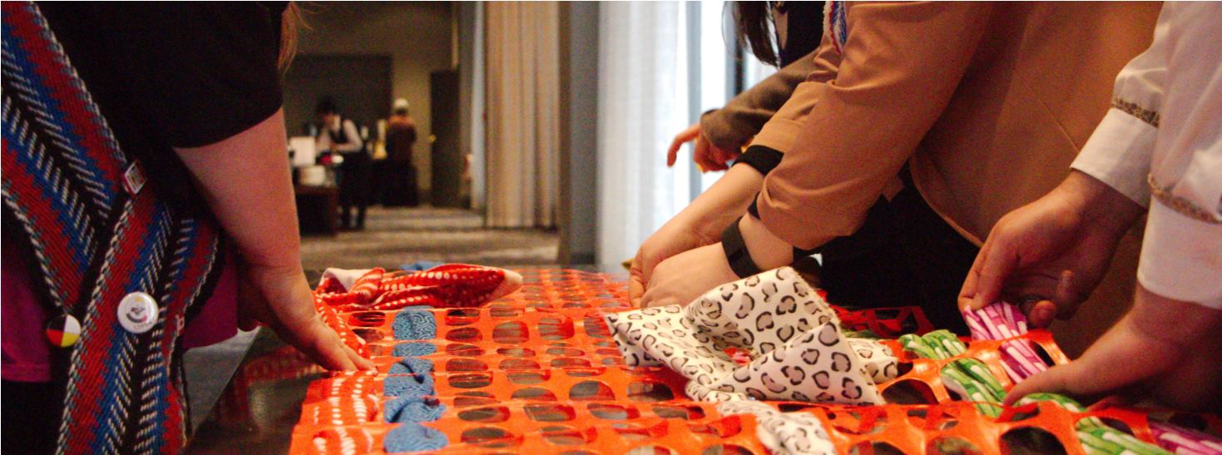

Each colour used in the sash has a specific meaning:
Red: Symbolizes the blood of the Métis that was shed through years of rebellion.
Blue: Symbolizes the depth of the Métis spirit.
Green: Symbolizes the fertility of a great Nation.
White: Symbolizes the Métis connection to the Earth and our Creator.
Yellow: Symbolizes prosperity.
Black: Symbolizes the dark period of the suppression and dispossession of Métis land.
Woven together, these colours represent all aspects of what it means to be Métis. As of 2016, the Métis population in Canada rose to 587,545. The Métis had the largest increase of any of aboriginal group, rising 51.2% from 2006 to 2016. 89,405 of identified Métis people live in the province of British Columbia.
To complete this activity you will need approximately 6-10 feet of snow fencing, your fabric should be approximately 8-12 feet longer than the fencing, allowing for pieces to hang off as fringe.
Participants will work together to weave the coloured lengths of fabric through the snow fencing, just while reflecting on the symbolic meaning of the colours, and how Metis history is interwoven in Indigenous and Canadian history.
Information retrieved from:
Canada, Statistics Canada. (2017). Aboriginal peoples in Canada: Key results from the 2016 Census (Vol. Catalogue no. 11-001-X). Ottawa, BC: The Daily. Retrieved May 04, 2018, from http://www.statcan.gc.ca/daily-quotidien/171025/dq171025a-eng.pdf
MNBC Grade 4 Cross Curricular Teacher Guide, 2016

