Storywork Give Away for Educators
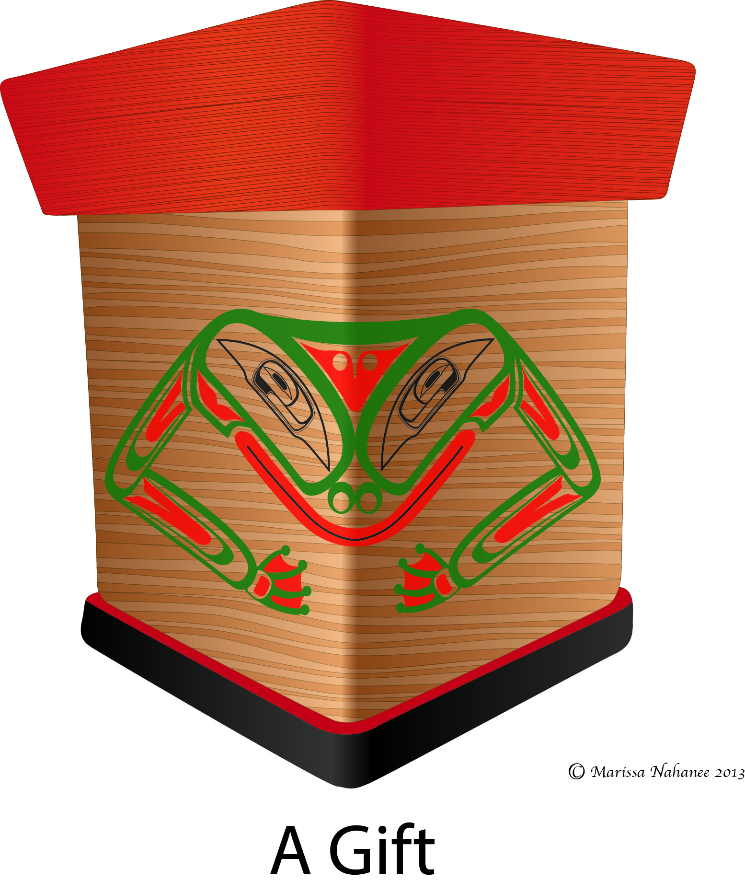

To begin, I raise my hands high to the Musqueam, Squamish and Tsleil-Waututh Peoples for allowing me to live, study and work as a guest within their traditional and unceded traditional territories. My name is Amy Parent and my Nisga’a name is Nox Ayaa Wilt (one who is close to her mother). On my mother’s side of the family, I am Nisga’a from the Nass Valley of Northwestern British Columbia. We are part of the McKay family, from the House of Ni’isjoohl and belong to the Ganada (Frog) Clan. On my father’s side, I am French and German. I am committed to working with Aboriginal youth, Indigenous communities, and institutions in order to identify proactive ways to transform the educational opportunities available for all learners. This give away has been undertaken in this spirit.
This give away is derived from my personal and professional experience working in Aboriginal organizations and educational contexts across the Province of British Columbia. It is also based on my understanding of the First Nations Educational Steering Committee’s (2012) “In Our Own Words: Bringing Authentic in the K-3 Classroom”; as well as my collaboration and on-going discussions with Dr. Jeannie Kerr. It is also important to acknowledge and thank all the individuals, communities, and organizations who have contributed to development of the resource.
I would also like to start by acknowledging the generousity of the Musqueum, Squamish and Tsleil-Waututh peoples, and particularly Elder Larry Grant for welcoming me to study and work as a guest on their ancestral, unceded and traditional territories. I am a first generation Settler known as Jeannie Kerr and my mother is from the Couch family of Cork County Ireland, and my father is ancestrally from the Kerr Clan of the Scottish Borderlands and more recently from Glasgow. I am committed to working with teachers, teacher candidates and instructors to help create educational spaces that work to repairing and renewing relations between Indigenous communities and peoples and the waves of Settlers/Immigrants that have come to what is known as Canada over hundreds of years. This collaborative document with Amy Parent is approached in this spirit, and is informed by my study with Indigenous scholars in this region of the world, and extensive readings from Indigenous scholars here and in different parts of the world. My collaboration with Amy Parent informs my understanding in a significant way.
This giveaway is intended to provide a beginning pathway to incorporating Aboriginal stories into your classroom. By following the suggestions provided here and remaining open to respectful dialogue and meaningful consultation with members of local Aboriginal communities, teachers will not only benefit their students but expand their own comfort in working with Aboriginal stories, knowledges and pedagogies. It is important to remember that while mistakes will inevitably occur (as in any educational undertaking), no error arising from the application of the suggestions provided here will prove as serious as the mistake of failing to work toward a more accurate portrayal of the diversity of the realities that encompasses Aboriginal learners in the classroom (FNESC, 2012).
Story, “Legend”, and “Myth”

According to FNESC (2012) “Because of the connotations often associated with the terms “legend” and “myth” (i.e.,fiction), it is preferable to use the term “story” or “traditional story.” In the 1997 Delgamuukw decision of the Supreme Court of Canada Chief Justice Lamar recognized in law that oral histories both embody historical knowledge and express cultural values (Grant, 2007). With this being said, it is still quite common to find older literature that utilizes these terms, even when it has been written in collaboration with Indigenous peoples and communities. As more communities work toward protecting and revitalizating Indigenous knowledges they have also chosen to reframe and re-position these incredible sources of knowledge as stories in order to move away from any misunderstandings about the power and truths that are embedded in them.

If students ask “Is the story true? Did this really happen?” there are a number of responses that might be appropriate, depending on the specific story, the context, and the age of the
children. Consider the following replies:
- “Sometimes you have to figure out for yourself what you believe to be true. Here’s what I think is true ...”
- “There is more than one way of understanding the truth. In many Indigenous cultures multiple truths and understandings of a story can exist. Nevertheless the story always maintains a consistent core that endures through time”
- “This story has many layers of understanding. I understand one of the key purposes/moral of this story to be ____, and that’s the most important truth.”
- “Many of the Chehalis people [for example] believe this story to be true.”
- “This story is so old that no one can say if it is true or not.”
- I wasn’t around when this story came about so I cannot tell you if it is or is not true,
but I hope you enjoyed it, or learned something from it.”
- “According to many Indigenous cultures, the great spirit[or Creator] gave us all the gifts that we have, and we are all individuals with different ways of seeing. That’s why we have differing beliefs, practices, clans, crests, and Nations.” (This response is of particular relevance when discussing any differences in the teachings of two or more stories) (adapted from page10).

Storywork Do’s

Avoid…
□ Appropriating Aboriginal stories, songs, dances, designs, crests, audiovisual materials and dances.
For example, if you do not introduce the source of your story, the community it originates, and whether or not you have been given permission to share the story, you will be appropriating it. It is important to recognize that local cultural protocols exist. Permission for use of First Nations cultural materials or practices such as stories, songs, designs, crests, photographs, audiovisual materials, and dances should be obtained from the relevant individuals, families, Elders, hereditary chiefs, Band Councils, or Tribal Councils (FNESC, 2012). First Nations Peoples and communities themselves contain the most accurate and authentic source of teaching about First Nations — their traditions, environments, ecologies, directions, priorities, etc. Authorization should be obtained prior to the use of any educational plans or materials. Consult your local district Aboriginal contact for advice and assistance in approaching the appropriate person(s). It is also important to distinguish between private and public stories. Some stories are sacred and cannot be shared with outsiders. Although, demonstrating for students the protocol of providing the geneology of the story and your reasons for sharing the story are still required, as well as sharing the location of the territory, historical relationships and some of the community’s values. Also, many stories have been published without permission or knowledge of the community and you should continue to use the points of assessment of published stories and educational materials that I have attached. I also highly recommend that you read all of Jo-ann Archibald’s seminal book (2008) on storywork.
□ The “Beads and Feather” Approach
Also known as the “Add on Approach” or the “Add and Stir Approach” describes an attempt to enrich curricula and pedagogy by adding Aboriginal content. This approach attempts to dress up pre-existing methods at a superficial level to make it appear culturally relevant for Aboriginal learners. Adding a lesson on “Aboriginal culture” (notice the “s” is missing) and using First Nations cultural information as the context for the teaching of subject matter is an example of this approach. According to Richardson and Blanchett Cohen (2000) “It does not require fundamental change. In essence it is a pragmatic approach which may offer a mild sense of inclusion to Aboriginal students in majority culture educational settings” (19). This approach is aligned with multiculturalism and is seen as a way to include ‘Aboriginal culture’ into mainstream institutional structures. Therefore it requires the least effort to implement and does not require fundamental systemic transformation. An example of the “beads and feather” approach is sharing a Nisga’a origin story and then having students participate in a written exercise that asks them to identify all relevant nouns that can be found in the story. Another common example, includes asking students to make toilet paper totem poles after reading a Haida story that was illustrated by Bill Reid. The difference between a multicultural ‘beads and feather approach’ and a respectful IK centred approach is that the first is framed around a “learning about” orientation whereas the latter is a “learning from” approach. It is important to frame our activities so that students are “learning about” the Haida Peoples, but instead implement practices within the classroom that allow us to invite students into a conversation about Haida knowledge and perspectives. We can collectively think about global and local challenges in a way where we “learn from” the Haida about such things as sustainable land practices, peaceful living, child rearing etc. The important distinction from an IK centred approach is that Haida (and all Indigenous peoples) are knowledge holders and not objects of study. This means framing our educational system around important questions and consulting multiple perspectives on how to understand and address our collective questions – recognizing that perspectives of Indigenous peoples on the territory and in the region where questions are raised is a priority.
□ Trying to separate spirituality from Aboriginal stories and Indigenous knowledges.
Any attempt to understand IK must begin by acknowledging the vital connection between all living and non-living beings, spiritual entities, Mother Earth and the Creator. Whether the topic at hand is education, science or art all learners must acknowledge the importance of creation and spirituality as fundamental aspects of IK. This wholistic conception clashes with the dominant modernist worldview that values secularism, segmentation, polarization, fragmentation, and abstraction, and is foundational to the discourse and curriculum in Western educational spaces. Awareness of this contrast, instead of the dismissal of this difference, should be a focus of the educational conversation in the classroom.
□ Missing out on utilizing important pre-recorded audio visual resources to help convey key stories and IK principles
It is important to engage multiple Indigenous perspectives in the classroom. There are rich on-line resources that can help you engage with the incredible diversity of Indigenous perspectives. It is often a common desire by educators to bring in an Elder or First community members make appearances for people that want to learn directly from them, but also the incredible and unsustainable demand of spending one's life in unpaid work to educate non-Indigenous peoples. Many people are choosing to spend their time teaching their community members as a priority as they reclaim their practices, territories and languages. It is important to first consider the places you would be likely to teach and the ways the voices and perspectives have been recorded or sustained for educational purposes. For instance, the Musqueam First Nation partnered with the Richmond Museum and Heritage Centre to provide an educational resource to be used in classrooms to educate about Musquem perspectives and values. Also, the Musqueam First Nation has established a Cultural Centre that is open to field trips. The Museum of Anthropology is also active in partnering with First Nations with exhibits and educational resources. School Boards have connections through district and school personnel that you can connect with to enrich your educational plans. There are also community events open to the public that you can attend and help to make yourself more personally knowledgeable. The important point is that relationships with Indigenous peoples and Nations should not be forged instrumentally or lightly, but are a long and sustained commitment that will happen over time.

Assessing Indigenous Resources for Classroom Use
How do we know if a resource is appropriate?
Deciding whether or not to use a resource that centres Indigenous knowledges, perspectives or stories can be difficult without some ways to think about the resource and your own ability to understand if it might be appropriate for the classroom. Based on ideas from Marie Battiste (2008) the following points should help you in your journey of looking at the available First Nations educational content and literature.
Author Introductions: The authors should clearly identify themselves, elaborate connections to other organizations, identify themselves with specific First Nations communities, and provide some legitimate or specific reasons for sharing the content. There should be some specific indication of “Who we are” and “why we are sharing” that benefits First Nations communities.
Providing a Context: The authors should not portray content as being authoritative knowledge of all First Nations, but should provide perspectives that are specific to the authors’ interests, affiliations and background. The content should have a history and context. You might want to ask the following types of questions: Which Nation did this come from? What is the history of this knowledge in its context with this Nation?
Complex and Contemporary Portrayals: The content should be free of language that places Indigenous Knowledge as being simple, quaint, exotic, and/or a relic of the past. The language should reflect cultural knowledge as alive, fluid, complex and applicable in a contemporary context. First Nations peoples should be portrayed in human complexity in the resources, and not as cultural stereotypes. Information should highlight the diversity among First Nations that stems from differing histories, cultures and traditions.
Avoid “Issue” Language: First Nations peoples and cultures should not be referred to as being an “issue”. Materials with a negative bias should be absolutely avoided.
Seek out the Recommendations: Look for recommendations of the resource from community elders and organizations that have a history of service to First Nations communities such as the First Nations Education Steering Committee, Aboriginal Healing Foundation and partnership organizations such as British Columbia Teachers Federation, or from mentors that you would trust. Despite the importance of the recommendation, you should question any materials that seem to not hold to the above points. Finding a resource on a large website (however reputable the host of the site is) does not constitute a recommendation.

Bibliography
Battiste, M (2008). The struggle and renaissance of Indigenous knowledge in Eurocentric education. In M. Villegas, S.R. Neugebauer, & K.R. Venegas (Eds), Indigenous knowledge and education: Sites of struggle, strength, and survivance (pp. 85-91). Cambridge, MA: Harvard Education Review Reprint Series No. 44
Richardson, C. & Blanchet-Cohen, N. (2000). Adult education and Indigenous peoples in Canada. Retrieved from www.unesco.org/e....f/Canada.pdf
First Nations Education Steering Committee (2012). In our own words: Bringing Authentic First Peoples content to the classroom to the K-3 classroom. Retrieved http://www.fnesc.ca/wordpress/wp-content/uploads/2011/03/In-Our-Own-Words-final-Apr-16-web.pdf

This image was created in collaboration with Marissa Nahanee of the Squamish & Nisga’a Nations for my doctoral research. Marissa has given me permission use this image for educational purposes that will enhance the well-being of Indigenous youth. Marissa retains the copyright to this image and asks that it is not used in any other context without her permission.

