Idea of the Day
Cedar Harvesting – Candace

Big Idea – ADST
- Technologies are tools that extend human capabilities.
- The choice of technology and tools depends on the task.

About the Movie
In this video, Candance and Lise are harvesting cedar bark. Candace and Lise use some tools to make the job easier. First Candace uses an ax to make a cut into the tree. What do you think First Nation people might have used to make this cut before axes where available?

Notice that the bark is not coming off the tree as easily as it should. Candace attaches a piece of rope to the end of the detached bark. How does this help?

First Nation Peoples in BC used all kinds of technology before contact. They were skilled at harvesting cedar bark. They knew the time of year to harvest it (spring – when the sap is running). They knew never to take too much bark from the tree because this could kill the tree and they knew how to make things from it.

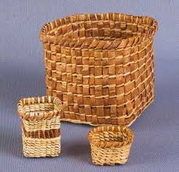
Cedar baskets

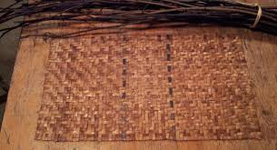
Cedar Mat

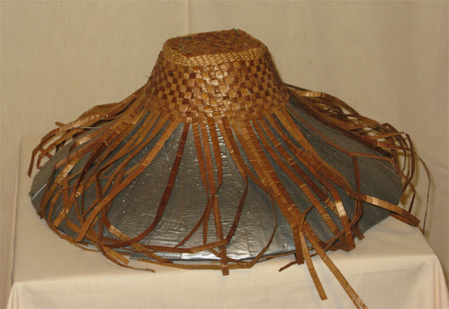
Cedar Hat

Notice that all these things are made from strips of cedar. This is the inner bark of a red cedar tree. Today we have tools to strip the cedar into even strips but before contact, these tools were not available.

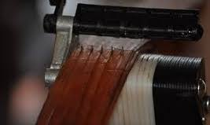
Leather Stripper Cedar is soaked in water, cut and then pulled
through stripper to make even strips

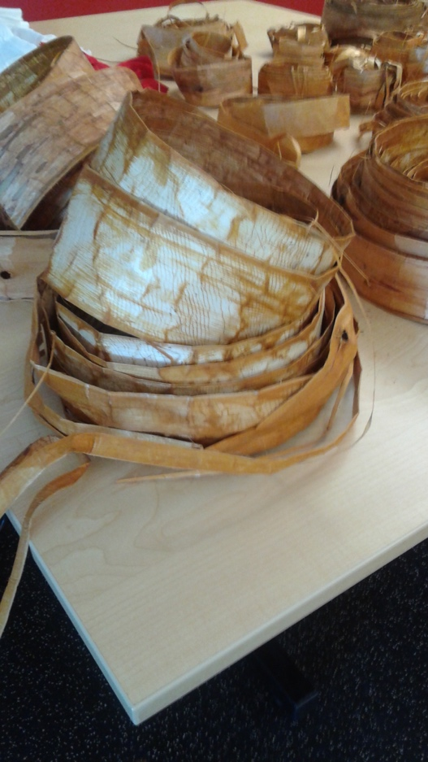
Strips of cedar bark – inner bark

Activities:
- Your task is to draw a design of a tool with existing resources from the land that could have been used to strip cedar. Look at the hat, the mat and the baskets. See how thin the strips need to be? Draw a design of a tool that could strip the cedar. Remember, design the tools of existing resources on the land. You can’t use steal. You can’t use anything you would buy in a store.

- Use the paper cedar strips and make a cedar mat or basket. You can use wool to secure your project.

