Beading Lesson and Playing Waltes

Lesson
Students made beaded counters. Look at beading samples and talk about about:
- Patterns (by colour)
- Patterns (by shape)
- Patterns (by materials)
- Patterns (decreasing and increasing patters)

Introduction
Talk about the history of beading. Beading is often part of pow wow regalia. The patterns and designs on the regalia are tailor fitted for the dancer. This means the artist must know a lot about the dancer.

Talk about man-made and natural beads. Pre-contact, Indigenous people used materials found in their local environment (Shells, bones, seeds, stones, wood, antlers, teeth). After contact, Indigenous people had access to glass beads.

Talk about the diversity of patterns in beading and how the patterns, materials used and designed reflect the Indigenous community of the artist.

What students did:
Students made a 10’s counter. They used this counter to keep track of their score in a MiKmaq game called Waltes.

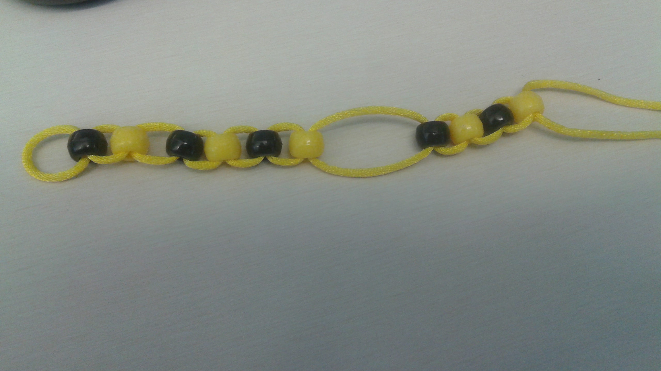

Playing Waltes

Read book, Let’s Play Waltes A Traditional Mi’kmaq Game – Kyla Bernard

Materials:
- A wooden bowl (maple if possible)
- Six 2 sided counters (coins will work)
- Cloth
- 10’s counter

Students place the counters all face down in the bowl. Lift the bowl up and bang it down on the cloth. Count how many dice land face up.

How to Score in Waltes
- 5 the same = 1 point
- 6 the same = 5 points
- All other combinations = 0 points

If the counter falls out of the bowl – miss a turn
To win: be the first to get 10 points.

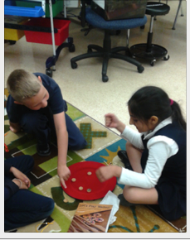

More Information: http://www.muiniskw.org/pgCulture1f.htm

