The Water Walker – developed by Bertha Lansdowne
Grade: 2

Big Idea:
Water is essential to all living things, and its cycle through the environment
____________________________________________________________________________

Lesson 1: Reading The Water Walker
Time: 1 hr 15 minutes

Curricular Competencies:
- Questioning and predicting
  - Demonstrate curiosity and a sense of wonder about the world
  - Ask questions about familiar objects and events
  - Make predictions about familiar objects and events
- Processing and analyzing data and information
  - Recognize First Peoples stories (oral and written), songs, and art, as ways to share knowledge
- Evaluating
  - Consider some environmental consequences of their actions
- Applying and innovating
  - Take part in caring for self, family, classroom and school though personal approaches
- Communicating
  - Express and reflect on personal experiences of place

Content:
- Local First People’s knowledge of water:
  - Water cycles
  - Conservation
  - Connection to other systems (cultural significance of water)

Materials:

- The Water Walker by Joanne Robertson (available through the Media Center)
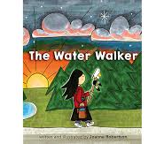
Based on a true story, the Water Walker challenges readers with the question, “What are you going to do about it.” It describes the Water Walks that an Anishinaabe grandmother, Josephine Mandamin, started to raise awareness around the need for water protection. After walking around the Great Lakes, and eventually, North America, has her campaign had an impact?

- Map of Anishinaabe https://en.wikipedia.org/wiki/Anishinaabe
- The Story of Turtle Island (https://www.youtube.com/watch?v=cX4GJTtSigY)
- Turtle Island template for students (attached)
- Song: The Water Song by Doreen Day (http://www.motherearthwaterwalk.com/)

Indigenous Connection:

- The Story of Turtle Island (attached)
- First Peoples Principles of Learning
  - Learning ultimately supports the well-being of the self, family, community, land, spirits and ancestors
  - Learning involves recognizing the consequences of one’s actions
  - Learning involves generational roles and responsibilities

Activities:

Accessing Prior Knowledge:

Teacher will introduce Indigenous perspectives by viewing the map of the Anishinaabe, and showing them where the Anishinaabe live in Canada:
https://en.wikipedia.org/wiki/Anishinaabe

Explain that the story will be from an Anishinaabe perspective, and discuss the concept of
“Turtle Island”, or, read and discuss the story of Turtle Island first (attached)

Review with students what they already know about the water cycle. Mention that the story will be connected to the water cycle, as well as the importance of protecting water and keeping it free from pollution so that there is clean water for everyone to drink and for plants and animals to survive.

Before Reading:

Show students the book cover, and have them partner talk about the words and pictures on the cover. Have each pair make a prediction about the story. After predictions are shared, begin reading the story, stopping along the way for students to predict, reflect and make connections. Have students “walk-to-talk” as needed.

During Reading:

Stop on page 1 and 2. Ask students to infer: Who or what is Nibi? Who or what is Nokomis? Explain that Nokomis means “Grandmother” in Anishinaabe and that “Nibi” means water. (See back of book for pronunciation clues). Continue reading to students.

Stop on page 9 and 10. Have students examine the pictures, and describe what is happening in them. Have them provide examples of how “people were disrespecting the water, wasting it, and making it unfit for life. If time permits, have students make connections to their own communities. How do people in our community disrespect or waste water?

Stop on page 13 and 14. Ask students to predict “What are the water walkers going to do? Why are they carrying a copper pail of water? Where are they going with the water?

Stop on page 15 and 16. Ask students to describe how the Water Walkers pay respect to Nibi (Water).

Stop on pages 18 and 19. Examine the illustration on page 19?

What are the implications? Have students walk to talk, making predictions/inferences about what will happen. Share as a group.

After Reading:

Review the story orally. Ask students to respond to the question “What are you going to do about it?” The goal is for students to make personal connections to the ideas presented in the book and to discuss personal approaches to dealing with the issue of water conservation.

Remind students that “Turtle Island” represents North America.

Distribute Turtle Island templates. Students will draw a picture or write out a pledge that they can make to protect and show respect to the water in the next lesson.

If time permits, Play the “Water Song” shown in the link above. . Explain that the water song was created by Doreen Day, an Anishinaabe grandmother, to bring awareness to the water walk, and that the songwriter has given permission for all people to use it. Alternatively, you can play some peaceful music that the students enjoy while they think about their pledges.

____________________________________________________________________________

Lesson 2: Cleaning Up An Oil Spill
Time: 1 hr 15 minutes

Curricular Competencies:
- Questioning and predicting
  - Demonstrate curiosity and a sense of wonder about the world
  - Observe objects and events in familiar contexts
  - Make simple predictions about familiar objects and events
- Planning and conducting
  - Safely manipulate materials to test ideas and predictions
- Processing and analyzing data and information
  - Compare observations with predictions through discussion
- Evaluating
  - Consider some environmental consequences of their actions
- Applying and innovating
  - Transfer and apply learning to new situations
  - Generate and introduce new or refined ideas when problem solving
- Communicating
  - Communicate observations and ideas using oral or written language, drawing, or role-play
  - Express and reflect on personal experiences of place

Content:
- Local First People’s knowledge of water:
  - Water cycles
  - Conservation
  - Connection to other systems (cultural significance of water)

Materials:

- Per group of approximately 4 students:
  - Large container (mixing bowl, plastic basin, or rubber tub)
  - Items for cleaning:
    - Spoons for scooping out particles
    - Small cup or measuring cup for scooping out water
    - Sieve or fine strainer
    - Cheese cloth (30 cm by 30 cm is sufficient)
    - Paper towels, napkins, or bathroom tissue
    - Container for collecting the “pollutants”
  - Small cup/jar for collecting “clean” water (250 ml works)
- Tap water
- Items to “pollute” the water:
  - Coffee grounds or clean soil
  - Sand or fine gravel
  - Shredded paper or pencil shavings
  - Black Oil (Mix cooking oil with activated charcoal to make black colour)
- Turtle Island templates for writing pledges
- 3 ft. by 4 ft blue paper, or white paper coloured blue to represent the ocean

Activities:
Ahead of time, fill large containers about halfway with tap water (enough for groups of approximately four students). Add to the water the items to “pollute” the water and give a quick stir. Do not add the oil yet! Make sure each group also has a set of the items for cleaning.

Review The Water Walker with students; show them the picture with the oil spill/pollution on pages 9 and 10. Discuss the effects of pollution on drinking water, recognizing the importance of keeping water clean for drinking, and mention how many communities in Canada and around the world do not have access to clean water.

Explain to students that they will be doing an experiment where they will need to work together to “clean” dirty water using the materials provided. Here are some suggestions to give:
- They do not have to use all of the materials
- They should consider the task and decide together how to proceed before “diving in”
- Predict how well they can “clean” the water--what will be the easiest/hardest items to clean? (you should let them know what is in each dirty water container)
- Encourage students to experiment with different strategies
- Use the bowl/plate/container to put the garbage in
- The goal is to save as much clean water as possible (and not to toss it along with the waste!)

After about 15-20 minutes, when most of the “easy” garbage has been removed but before they are finished, let them know that an “OIL SPILL” is about to happen in their water. Then pour a small amount of the black oil into each basin (do not mix...they will inadvertently do this!)

Have students work together to find the best strategy for removing the oil. After most of the oil is removed, let students know they will need to fill a small container with the “clean” water that is good enough to drink (do not let them drink it!) They may only have a few minutes left at this stage. The purpose of doing this is to save time (they will never be able to fully clean the water) and to make them connect the idea that people have to drink “cleaned” polluted water.

Once the time is up, debrief the experiment. Ask students:
- What strategies did you use?
- What worked well? What did not work so well?
- Which items were easy to clean and which were difficult?
- What would you do differently next time?
- What did you learn about cleaning water and oil spills?
- What have you learned about water conservation?

You want students to come away with the idea that it is difficult to clean water--especially oil spills! (There’s always some oil particles left.) You want them to realize the importance of conserving water and to reflect on what they can do in their own lives to conserve, protect, and show respect for water.

Ask students to think back to the story of The Water Walker and have them finish writing down/drawing a picture of the pledge they will make to protect water from pollution, or a promise they will make to conserve water.( Use the cut out turtle shapes for their pledges.)

Help students assemble the pledge turtles on a large blue paper, and arrange the small turtles in the shape of a large turtle to represent Turtle Island. If it’s helpful, sketch the shape of a large turtle (bird’s eye-view) and students can glue their pieces inside the shape.

Tape the turtle collage to a wall in the classroom or hallway to remind students about their pledge and their responsibility to do their part as water protectors.

____________________________________________________________________________

Ideas for Assessment:

Science Learning Standards:
The Indigenous Perspectives address the content standards. For the curricular competencies, observations during the Cleaning Up An Oil Spill task will give you the formative assessment necessary to be able to provide dedicated feedback to students during the task as well as to assess the students’ understanding of the importance of water conservation.

Student pledges can also tell you what a student has learned over the past two lessons. Conferencing may be necessary to get more information. Look fors include:
- Personal (not general) ways in which a student can conserve water (e.g., at home or while at school)
- An indication of the importance of water for self, others, and all life
- An indication that students understand the difficulties in cleaning polluted water
- Use “I can …statements for the Core Competency “Personal and Social Responsibility”
I.e. Describe how your actions have helped make your classroom, school, community or the natural environment a better place.

Map of the Anishinaabe People (known to Westerners as Ojibwa)

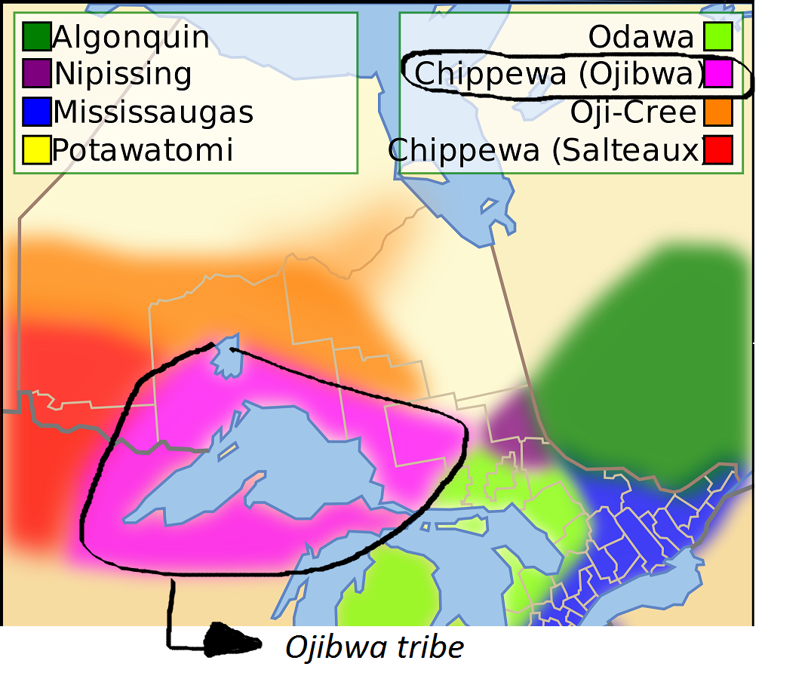

An Ojibway Story of Creation - Pic River First Nation
https://www.youtube.com/watch?v=cX4GJTtSigY

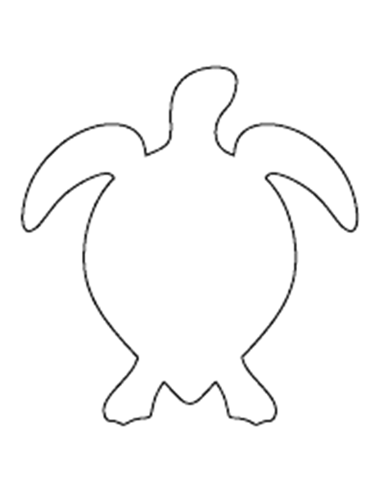

Template for Turtle Pledges

